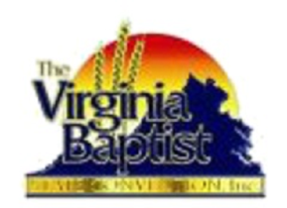
The Virginia Baptist State Convention, Inc.
State Department of Christian Education
VBSC Virtual CLS School

CLS 1001
Introduction to
the Bible
Dr. Veronica Haynes
9/17 through 10/15
Course Fee is $10

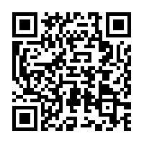

“Click Here or Scan
the QR Code to Register!”

Course Schedule
Virtual Learning Orientation Seminar:
September 17, 6:30PM EST
LaShell Currie and Kesha Reynolds
September 24, 6:30PM EST 1001 Introduction to the Bible
October 1, 6:30PM EST 1001 Introduction to the Bible
October 8, 6:30PM EST 1001 Introduction to the Bible
October 15, 6:30PM EST 1001 Introduction to the Bible

COPY AND PASTE to Web Browser
https://zoom.us/meeting/register/tJUvduiuqTIqEtTr4FMVNuErlJpXapGhfHao

