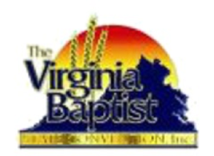
The Virginia Baptist State Convention, Inc.
State Department of Christian Education
VBSC Virtual CLS School
CLS 1004
Effective
Bible Reading
Dr. Veronica Haynes
10/22 through 11/13
Course Fee is $10

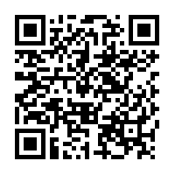

“Click Here or Scan
the QR Code to Register!”

Course Schedule
October 22, 6:30PM EST 1004 Effective Bible Reading
October 29, 6:30PM EST 1004 Effective Bible Reading
November 5, 6:30PM EST 1004 Effective Bible Reading
November 12, 6:30PM EST 1004 Effective Bible Reading
CLS 2021 CLOSING SEMINAR: FRIDAY, NOVEMBER 13, 6:30PM EST
“Developing the Christian Leadership School of the NBC”
Dr. Geoffrey V. Guns / Dr. Luther S. Allen III

COPY AND PASTE to Web Browser
https://zoom.us/meeting/register/tJwod-mgqDoiE9ab5T_o5RWaVchZe3Pn6bO0

